

TOURISM MANAGEMENT SYSTEM

Software Analysis And Design 2025

Software Engineering

Submitted by: Luis Sulaj & Mateo Tanuçi

Approved by: Dr. Igli Hakrama

Table of contents

1.Overview

2.Stakeholders

2.1.Stakeholders Table

2.2.Onion Diagram

3.Requirements

3.1.Functional Requirements

3.2.Non-functional Requirements

4.User Stories

5.Use Cases

5.1.Use Case Diagram

5.2.Use Case Table

6.UML Modeling

6.1.Data Flow Diagram

6.2.Entity Relationship Diagram

6.3.Class Diagram

6.4.Object Diagram

6.5.Sequence Diagram

6.6.Collaboration Diagram

6.7.Activity Diagram

6.8.State Diagram

6.9.Package Diagram

7.Component Diagram

8. Business Process Model and Notation

9.Design Patterns

9.1.Behavioral Design

9.1.1.Observer Pattern

9.1.2.Strategy Pattern

9.2.Creational Design

9.2.1.Factory Pattern

9.2.2.Singleton Pattern

9.3.Structural Design

9.3.1.Decorator Pattern

10.Physical Design

10.1.Deployment Diagram

11.User Interface

1.Overview

The Tourism Management System is a digital platform designed to enhance the travel experience by providing seamless access to essential tourism services. From discovering attractions to booking accommodations and managing travel itineraries, this system offers a comprehensive suite of features tailored for modern travelers.

**Key Features**

* **Explore Attractions** – Discover historical sites, cultural landmarks, and natural wonders.
* **Hotel & Accommodation Booking** – Compare and book hotels with real-time availability.
* **Transport & Travel Options** – Book flights, trains, buses, and car rentals.
* **Tourist Activities & Events** – Book tours, outdoor adventures, and cultural experiences.
* **Travel Safety & Alerts** – Get emergency contacts, travel warnings, and safety updates.
* **Secure Payments** – Multiple payment options, including credit cards and PayPal.
* **Multilingual Support** – Available in several languages for global accessibility.
* **Map Integration** – Google Maps API / Mapbox.
* **Payments** – Stripe / PayPal.

**Why Use This System?**

Designed for travelers, tourism agencies, and hospitality businesses, this system simplifies the process of travel planning, providing a seamless and efficient experience.

2.Stakeholders

2.1.Stakeholders table

|  |  |  |  |  |  |
| --- | --- | --- | --- | --- | --- |
| **Stakeholder** | **Stakeholder Role/Responsibility** | **Importance** | **Influence** | **Interests/ Positive Impacts** | **Concerns** |
| Tourists | Individuals who will use the portal to plan and book their trips to Albania. | HIGH | HIGH | Accessing information about attractions, accommodations, activities, transportation, and events, booking services, reading reviews, and having a seamless user experience. | Usability, Information Accuracy, Privacy, Language Barriers, Payment Security. |
| Green Park Investment Group | Company’s role is to provide financial backing, oversee the project’s strategic alignment with business goals and manage risks. | HIGH | HIGH | Company is interested in making sure the system is profitable, supports business goals, runs smoothly, and follows all rules. | Staying on budget, meeting deadlines, getting good returns, and avoiding any problems with the system. |
| Accommodation providers | Businesses that provide accommodation ( hotels, boutique hotels, Airbnb-style rentals). | HIGH | HIGH | Attracting tourists to book their services, managing availability, and increasing visibility on the platform. | Room Availability, Pricing Control, Customer Reviews |
| Transportation Providers | Companies offering transportation services, such as buses, car rental agencies, and private transport services. | HIGH | HIGH | Gaining exposure to tourists, facilitating bookings, and providing details about routes, schedules, and availability. | Booking Accuracy, Payment Issues, Service Coverage |
| Activity Providers | Businesses or individuals organizing tours, events, outdoor adventures, or local cultural activities. | HIGH | MEDIUM | Promoting and booking their events and activities, managing schedules, and receiving customer feedback. | Competition, Pricing Transparency, Promotion |
| Local Communities and Villages | Local communities and villages that might offer unique experiences, such as rural tours, local crafts, food, and cultural experiences. | HIGH | MEDIUM | Showcasing local heritage and crafts, attracting tourists to their areas, and promoting sustainable tourism practices. | Over-Tourism , Unequal Benefits |
| Local Businesses and Restaurants | Restaurants, cafes, bars, and other businesses that cater to tourists. | MEDIUM | MEDIUM | Gaining visibility and attracting tourists to their establishments. | Competition, Customer Expectations |
| Travel Service Providers | Companies providing payment processing services (credit card, PayPal, mobile payments), currency converters. | MEDIUM | MEDIUM | Ensuring secure, seamless payment systems and currency conversions for international tourists. | Transaction Issues, Currency Conversion Accuracy, Fees |
| Government Tourism Authorities | National or regional tourism departments or ministries responsible for promoting tourism in Albania. | MEDIUM | MEDIUM | Promoting Albania as a tourist destination, improving tourism services, tracking data on tourism trends, and ensuring tourism safety. | Regulation, Local Impact, Economic Balance |
| Platform Developers and IT Team | Software developers, web designers, system architects, and IT support teams responsible for building and maintaining the portal. | HIGH | HIGH | Developing and maintaining a functional, user-friendly platform, integrating third-party services, and addressing any technical issues. | Downtime, Security, Scalability, Integration |
| System Managers | Individuals or teams responsible for managing and overseeing the portal, including data management, analytics, revenue tracking, and user support. | HIGH | HIGH | Ensuring the system operates smoothly, analyzing user data, promoting services, managing bookings, and generating revenue reports. | User Support, System Maintenance |

2.2.Onion Diagram

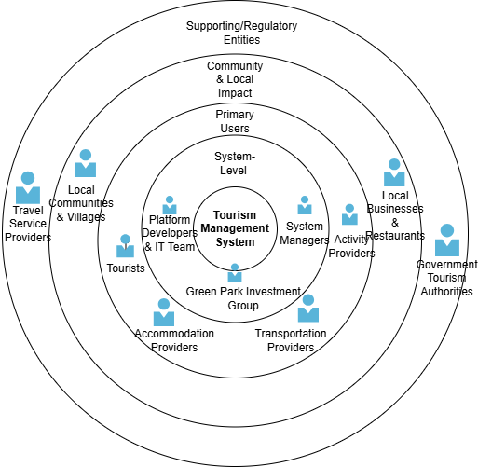

3.Requirements

3.1.Functional Requirements

1. **Tourist Information Portal**

* Attractions Database: The system should allow tourists to browse and view detailed information about Albania’s tourist attractions, including descriptions, images, opening hours, entrance fees, and user reviews.
* Cultural and Historical Insights: The system should provide a section where tourists can access information about Albania’s cultural heritage, including UNESCO World Heritage Sites, historical landmarks, and traditional practices.
* Travel Guides: The system should provide digital travel guides for tourists, featuring suggested itineraries for different regions of Albania, including the Albanian Riviera, Accursed Mountains, and Tirana.
* Interactive Maps: The system should provide interactive maps showing tourist destinations, accommodations, local restaurants, and transport routes. Users should be able to click on map markers to view more details.

1. **Accommodation Management**

* Hotel and Accommodation Booking: The system should allow users to search for available accommodations, filter by location, type, and amenities, and complete bookings for various types of accommodation.
* Availability Calendar: The system should display a real-time calendar showing room availability for accommodations, including detailed information on pricing, availability, and user reviews.
* Price Comparison: The system should allow users to compare prices for different accommodations, helping them find the best deals based on their preferences.

1. **Transportation and Travel Options**

* Transport Booking: The system should allow users to search for and book transportation options, including flights, buses, trains, and car rentals, with payment processing integrated into the platform.
* Public Transport Information: The system should display detailed schedules for Albania’s public transportation system, including bus and ferry routes, and provide real-time updates for arrivals and departures.
* Tour Packages: The system should allow tourists to browse and book pre-arranged tour packages that include transportation, guided tours, and activities for specific destinations or routes in Albania.

1. **Tourist Activities and Events**

* Activity Booking: The system should enable tourists to book a wide range of activities, including guided tours, nature hikes, adventure sports, cooking classes, and cultural events.
* Event Calendar: The system should feature a dynamic calendar listing upcoming festivals, concerts, exhibitions, and other events in Albania, with the option to book tickets.
* Outdoor Adventures: The system should provide detailed information and booking options for outdoor activities available in Albania’s national parks, such as trekking, hiking, and rafting.
* Local Experiences: The system should provide curated local experiences, such as visiting villages, wine-tasting tours, and learning about Albanian culture and traditions.

1. **Travel Safety and Alerts**

* Emergency Contacts: The system should provide easy access to emergency services information and tourist police for quick assistance.
* Travel Warnings: The system should notify tourists about potential safety risks or issues that may affect specific regions.
* COVID-19 Guidelines: The system should provide up-to-date information about COVID-19 regulations in Albania, including health protocols, testing and vaccination requirements, and other travel-related safety measures.

1. **Customer Reviews and Social Features**

* User Reviews and Ratings: The system should allow users to leave ratings and written reviews for accommodations, tours, and activities.
* Photo Galleries: The system should feature photo galleries showcasing user-submitted and curated images of Albania’s tourist attractions.

1. **Payment and Currency Support**

* Online Payment Gateway: The system should integrate with payment providers to allow users to securely make payments for bookings, tickets, and tours.
* Currency Converter: The system should include a currency converter tool that allows international tourists to easily convert their home currency to Albanian lek (ALL) for transactions.

1. **Multilingual Support**

* Language Options: The system should support multiple languages to accommodate international tourists, including at least English, Albanian, Italian, German, and French. The language preference should be configurable by users.

1. **Tourism Analytics and Reporting (Admin Dashboard)**

* Visitor Analytics: The system should provide an admin dashboard to track visitor activity, popular destinations, and user behavior trends, helping businesses improve their offerings.
* Revenue Management: The system should include features for tracking revenue from bookings, tours, and accommodations, with reports on overall financial performance.
* Promotions and Marketing: The system should allow admins to create and manage promotions, discounts, and special offers, to attract more visitors during off-peak seasons or for special events.

3.2.Non-Functional Requirements

**1. Performance**

* Response Time: The system should ensure that all user requests are processed within 3 seconds under normal usage conditions.
* Throughput: The system should support at least 1000 concurrent users without significant degradation in performance.
* Scalability: The system should be designed to handle increasing traffic and data over time.
* Availability: The system should be available 99.9% of the time to ensure continuous access to information for users, especially during high traffic periods like holidays or summer months.

**2. Security**

* Authentication and Authorization: The system should ensure that all users, including tourists and administrators, are authenticated through secure login mechanisms.
* Data Protection: All personal data, including payment information and personal identification, must be encrypted in transit using TLS/SSL and at rest using strong encryption standards.
* Secure Payment Integration: All payment transactions should be processed using PCI DSS-compliant payment gateways (Stripe or PayPal).
* Access Control: Different user roles must have appropriate access rights to sensitive system data and actions.
* Security Audits: The system should undergo regular security audits to identify and fix vulnerabilities.

**3. Usability**

* Multi-language Support: The system should be user-friendly and support at least five languages (e.g., English, Albanian, Italian, German, French).
* Mobile Accessibility: The system should be fully responsive, ensuring seamless access and usability across desktop, tablet, and mobile devices.
* User Interface: The platform should have an intuitive, visually appealing user interface (UI) that provides easy navigation, especially for non-technical users. The UI should load within 2 seconds.
* Error Handling: Clear error messages and guides should be displayed when an operation fails (e.g., failed booking, payment error), with suggested actions for users.

**4. Reliability**

* Data Integrity: The system should ensure the accuracy and consistency of data across the platform, including booking records, reviews, and transactions. Any system failure should not result in data loss.
* Backup: Regular backups of the database should be performed, with an automatic recovery process in place in the event of data corruption or system failure.
* Disaster Recovery: The system should include a disaster recovery plan to ensure quick restoration of service in the event of system downtime or failure, targeting a recovery time objective (RTO) of less than 4 hours.

**5. Maintainability**

* Code Quality: The system’s source code should adhere to industry best practices, including clear documentation and proper code structure, making it easy to maintain, upgrade, and troubleshoot.
* Logging and Monitoring: The system should have an integrated logging system for tracking user activities, error messages, and system performance. It should also include monitoring tools to track system health and performance metrics.
* Updates and Patches: The platform should be regularly updated to improve performance, patch security vulnerabilities, and add new features without significant disruptions to users.

**6. Compliance**

* Legal Compliance: The system should comply with all relevant legal regulations related to data protection and privacy.

**7. Interoperability**

* API Integration: The system should support APIs for integrating with third-party services such as payment gateways (Stripe, PayPal), map services (Google Maps), and external booking systems (for flights or car rentals).
* System Integration: The system should seamlessly integrate with existing third-party systems like hotel booking systems, transport companies, and payment systems.

**8. Localization and Internationalization**

* Currency Support: The system should automatically convert prices to the tourist’s preferred currency, using real-time exchange rates, and support multiple currencies.
* Time Zone Handling: The system should correctly handle time zones for booking activities, events, and accommodations, displaying accurate times based on the user's location.

**9. Auditability**

* Tracking User Actions: The system should log and track all user interactions related to bookings, transactions, and reviews. Admins should have the ability to view logs for auditing purposes.
* Transparency in Payments: Detailed reports should be available for tourists, administrators, and businesses for transparency regarding payment transactions, cancellations, and refunds.

**10. Support and Customer Service**

* Help and Support: The system should provide easy access to help resources, including FAQs, live chat support, and contact forms for tourists to reach customer service.
* 24/7 Availability of Support: Live customer support (chat, email, or phone) should be available 24/7 to address any urgent tourist concerns or technical issues.

4.User Stories

**High Priority**

**-Search for Options:** I as a Tourist want to search for accommodations/activities with filters (date, price, type) so I find matches quickly.

Acceptance: Real-time filter updates, Clear pricing/availability

**-Book Securely:** I as a Tourist want to book selected options online, so I secure my trip plans.

Acceptance: Instant confirmation Cancel/modify pre-payment

**-Pay with Trust:** I as a Tourist want to pay via PayPal/credit cards, so I transact securely.

Acceptance: PayPal/Visa/Mastercard

**-Use My Language:** I as a Non-English Tourist want to switch to Albanian/Italian, so I navigate comfortably.

Acceptance: Accurate translations Persistent language settings

**Medium Priority**

**-Share Feedback:** I as a Traveler want to rate/review hotels/tours, so others learn from my experience. Acceptance:1–5 stars + text Moderation system

**-Plan with Events:** I as a Cultural Tourist want to see local event calendars, so I align my trip with festivals.

Acceptance: Date/location filters Links to tickets

**Low Priority**

**-Get Recommendations:** As a Returning Tourist want personalized suggestions, so I discover new activities.

Acceptance: History-based algorithm Adjustable preferences

**-Check Weather**:I as a Planner want a 7-day forecast, so I pack the right clothes.

Acceptance: Temp/conditions/alerts Reliable API integration

5.Use Cases

5.1.Use Case Diagram

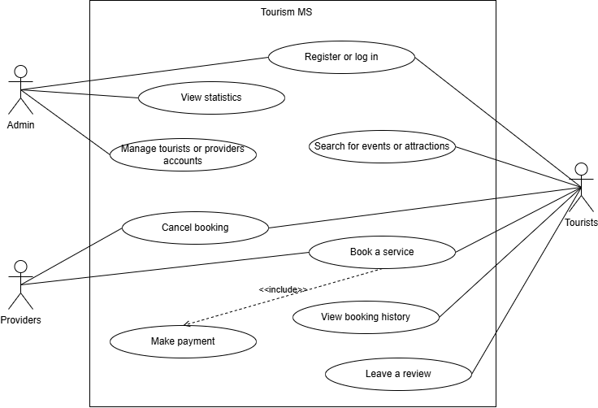

5.2.Use Case Table

**1. Book a Hotel Room**

The tourist searches for available accommodations by entering their travel dates and preferences, selects a hotel, and completes the booking process, including payment, to reserve their stay.

|  |  |  |
| --- | --- | --- |
| **Use case name:** | Book a hotel room | |
| **Scenario:** | A tourist books a hotel room through the system. | |
| **Triggering event:** | The tourist wants to book a hotel for their stay in Albania. | |
| **Brief description:** | The tourist searches for available accommodations, selects a hotel based on preferences, enters booking details, and completes payment to confirm the reservation. | |
| **Actors:** | Tourist | |
| **Stakeholders:** | Tourist  Hotel/AirBnB owners  Green Park Investment Group | |
| **Preconditions:** | The user must have access to the system and be logged in if needed.  The hotel system must have room availability for the desired dates. | |
| **Postconditions:** | The hotel room is successfully booked.  A confirmation message is sent to the tourist with booking details. | |
| **Flow of activities:** | **Actor** | **System** |
| 1. The tourist accesses the accommodation section. 2. The tourist enters destination, check-in, check-out dates, and guest details. 3. The tourist selects a hotel and views the available rooms. 4. The tourist selects a room and confirms the booking details. 5. The tourist enters payment information. | 2.1 The system displays available accommodations based on these criteria.  5.1The system processes the payment and confirms the booking.  6. A confirmation email/message is sent to the tourist with the booking details. |
| **Exception conditions:** | If no rooms are available, the system offers alternative dates or accommodations.  If payment fails, the system asks the user to re-enter payment details or try another method. | |

Figure 1: Fully developed use case description for “Book a Hotel Room”

**2. Search for Tourist Attractions**

The tourist browses and searches for tourist attractions in Albania, viewing detailed information about each site, including descriptions, images, and visitor reviews, to help plan their visit.

|  |  |  |
| --- | --- | --- |
| **Use case name:** | Search for Tourist Attractions | |
| **Scenario:** | A tourist wants to find and learn about various attractions in Albania. | |
| **Triggering event:** | The tourist is looking to explore and visit popular sites in Albania. | |
| **Brief description:** | The tourist browses different categories of attractions, reads descriptions, views images, and reviews to decide where to visit. | |
| **Actors:** | Tourist | |
| **Stakeholders:** | Tourist  Attraction owners and local businesses  Local government  Green Park Investment Group | |
| **Preconditions:** | The attractions database is populated with details of sites. | |
| **Postconditions:** | The tourist views a list of available tourist attractions with relevant details. | |
| **Flow of activities:** | **Actor** | **System** |
| 1. The tourist accesses the attractions section. 2. The tourist selects a category. 3. The tourist can view photos, descriptions, hours, and reviews for each attraction. | * 1. The system displays categories of attractions (beaches, mountains, historical sites, etc.).   2.1 The system displays detailed information about the selected attractions. |
| **Exception conditions:** | If no attractions are available in the selected category, the system suggests related attractions or nearby locations. | |

Figure 2: Fully developed use case description for “Search for Tourist Attractions”

**3. Book a Guided Tour**

The tourist selects and books a guided tour for activities like historical tours or nature hikes, choosing the date and making payment to confirm the booking.

|  |  |  |
| --- | --- | --- |
| **Use case name:** | Book a Guided Tour | |
| **Scenario:** | A tourist books a guided tour to explore a specific location or activity in Albania. | |
| **Triggering event:** | The tourist wants to explore Albania by booking a guided tour. | |
| **Brief description:** | The tourist selects a tour, chooses a date, and completes the booking with payment to confirm the tour reservation. | |
| **Actors:** | Tourist | |
| **Stakeholders:** | Tourist  Tour operators  Green Park Investment Group | |
| **Preconditions:** | The tourist has selected a tour to book.  The tour is available on the chosen date. | |
| **Postconditions:** | The tourist successfully books the tour and receives confirmation. | |
| **Flow of activities:** | **Actor** | **System** |
| 1. The tourist accesses the activities and events section. 2. The tourist searches for and selects a guided tour. 3. The tourist selects a date and proceeds to booking. 4. The tourist enters payment information. | * 1. The system shows available dates and pricing.   4.1 The system processes the payment and confirms the tour booking.  5. A confirmation email/message is sent to the tourist. |
| **Exception conditions:** | If the tour is fully booked, the system suggests alternative dates.  If the payment fails, the system prompts the tourist to re-enter payment details. | |

Figure 3: Fully developed use case description for “Book a Guided Tour”

**4. Provide Emergency Contact Information**

The tourist accesses emergency contact information and safety guidelines, including local emergency services and important alerts, to ensure their safety while traveling.

|  |  |  |
| --- | --- | --- |
| **Use case name:** | Provide Emergency Contact Information | |
| **Scenario:** | A tourist needs quick access to emergency services or safety information while traveling in Albania. | |
| **Triggering event:** | The tourist needs emergency contact details or safety alerts. | |
| **Brief description:** | The tourist accesses emergency contact information and safety guidelines, including numbers for local emergency services and health guidelines. | |
| **Actors:** | Tourist | |
| **Stakeholders:** | Tourist  Local authorities  Green Park Investment Group | |
| **Preconditions:** | The tourist has access to the system.  The emergency contact information is up-to-date and accessible. | |
| **Postconditions:** | The tourist has received the necessary contact details and safety guidelines. | |
| **Flow of activities:** | **Actor** | **System** |
| 1. The tourist accesses the travel safety section. 2. The tourist can view or call the emergency numbers directly. | * 1. The system displays emergency contact details (police, fire department, embassy, etc.).   2. The system shows any relevant safety alerts or guidelines (e.g., natural disasters, COVID-19 updates). |
| **Exception conditions:** | If the emergency contact information is unavailable, the system provides an error message or suggests alternative ways to reach emergency services. | |

Figure 4: Fully developed use case description for “Emergency Contact Information”

**5. Register as a Tourist**

A new user signs up to access the system's features.

|  |  |  |
| --- | --- | --- |
| **Use case name:** | Register as a Tourist | |
| **Scenario:** | A new user visits the Tourism Management System and wants to create an account to book accommodations, tours, or transportation. | |
| **Triggering event:** | The user clicks on the "Register" or "Sign Up" button on the homepage. | |
| **Brief description:** | A tourist creates an account by providing required information such as name, email, password, and optionally emergency contact info. Upon successful registration, the user gains access to personalized services. | |
| **Actors:** | Tourist | |
| **Stakeholders:** | Tourist  Green Park Investment Group | |
| **Preconditions:** | The user is not currently logged in.  The registration page is available and functioning. | |
| **Postconditions:** | A new user account is created in the system.  The user is either redirected to the login page or automatically logged in. | |
| **Flow of activities:** | **Actor** | **System** |
| 1. The tourist clicks "Register" on the homepage. 2. The tourist fills in required fields (name, email, password, etc.). 3. The tourist submits the form. | * 1. The system displays the registration form.   3.1 The system validates the input data.  3.2 The system checks if the email is already in use.  3.3 If valid, the system creates a new user account.  4. The system displays a confirmation message or logs the user in. |
| **Exception conditions:** | If the email entered is already registered the system displays an error message.  If required fields are missing or contain invalid data the system highlights errors and prompts for corrections.  If system/server error during registration the user is informed to try again later. | |

Figure 5: Fully developed use case description for “Register as a Tourist”

**6. Login to the System**

A registered user logs into their account.

|  |  |  |
| --- | --- | --- |
| **Use case name:** | Login to the System | |
| **Scenario:** | A registered tourist wants to log in to their account to make bookings or view personal information. | |
| **Triggering event:** | The user clicks on the "Login" button and enters their credentials. | |
| **Brief description:** | A registered tourist accesses their account by providing valid login credentials (email/username and password). Upon successful authentication, the user gains access to personalized services. | |
| **Actors:** | Tourist | |
| **Stakeholders:** | Tourist  Green Park Investment Group | |
| **Preconditions:** | The tourist has a registered account.  The system's login service is operational. | |
| **Postconditions:** | The tourist is logged into the system and redirected to their dashboard. | |
| **Flow of activities:** | **Actor** | **System** |
| 1. The tourist clicks the "Login" button. 2. The tourist enters their email/username and password. 3. The tourist submits the login form. | * 1. The system displays the login form.   3.1 The system validates the entered credentials.  4. If credentials are correct, the system grants access and redirects the tourist to their dashboard. |
| **Exception conditions:** | If incorrect email/username or password the system displays an error message and allows retry.  If tourist account is deactivated or blocked the system informs the user and denies access.  If the required fields are empty the system prompts the user to fill in the fields.  If the system/server error the system displays a general error message and suggests trying again later. | |

Figure 6: Fully developed use case description for “Login to the System”

**7. Update Personal Profile**

A user edits their contact info, preferences, or emergency details.

|  |  |  |
| --- | --- | --- |
| **Use case name:** | Update Personal Profile | |
| **Scenario:** | A logged-in tourist wants to update their profile information such as name, contact details, password, or emergency contact. | |
| **Triggering event:** | The tourist clicks on the "Edit Profile" or "Account Settings" option from their dashboard. | |
| **Brief description:** | This use case describes how a tourist modifies their existing profile information to ensure it is up to date. The system validates and saves the changes. | |
| **Actors:** | Tourist | |
| **Stakeholders:** | Tourist  Green Park Investment Group | |
| **Preconditions:** | The tourist is logged in.  The system has access to the user’s profile data. | |
| **Postconditions:** | The tourist’s updated information is saved in the database. | |
| **Flow of activities:** | **Actor** | **System** |
| 1. The tourist selects "Edit Profile" from their account menu. 2. The tourist updates one or more fields (e.g., name, phone, email, password, emergency contact). 3. The tourist submits the changes. | * 1. The system retrieves and displays the current profile information.   3.1 The system validates the input data (e.g., email format, password strength).  4. If valid, the system updates the user profile in the database.  5. The system confirms that the update was successful. |
| **Exception conditions:** | If invalid input format the system highlights the issue and prompts for correction.  If the required fields are left blank the system notifies the user to complete the form.  If system/database error the user is informed of the failure and asked to try again later. | |

Figure 7: Fully developed use case description for “Update Personal Profile”

**8. Book Transportation**

Tourists reserve transport like buses, taxi, or car rentals.

|  |  |  |
| --- | --- | --- |
| **Use case name:** | Book Transportation | |
| **Scenario:** | A logged-in tourist wants to reserve transportation such as a bus, taxi, or car rental for travel within Albania. | |
| **Triggering event:** | The tourist selects a transportation option and clicks the "Book Now" button. | |
| **Brief description:** | A tourist can reserve a mode of transportation, such as booking a scheduled bus, arranging a point-to-point taxi, or renting a vehicle. The system collects trip details based on the selected service type, checks availability, and confirms the booking, optionally including payment. | |
| **Actors:** | Tourist | |
| **Stakeholders:** | Tourist  Transportation Provider  Green Park Investment Group | |
| **Preconditions:** | The tourist is logged in.  Transportation listings are available and up to date.  The tourist has a valid payment method (if required). | |
| **Postconditions:** | A transportation booking is successfully created.  The tourist receives confirmation and booking details. | |
| **Flow of activities:** | **Actor** | **System** |
| 1. The tourist navigates to the "Transportation" section. 2. The tourist selects a service and enters trip details. 3. The tourist confirms the booking and proceeds to payment (if applicable). | * 1. The system displays available transportation options.   2. The system displays price and availability.   3.1 The system processes the payment and generates a booking confirmation. |
| **Exception conditions:** | If selected transportation is no longer available the system notifies the user and suggests alternatives.  If invalid or incomplete booking details the system highlights issues and prompts for correction.  If payment failure the system informs the user and allows retry or alternative method.  If system error during booking the user is notified and advised to try again later. | |

Figure 8: Fully developed use case description for “Book Transportation”

**9. Cancel a Booking**

Tourists cancel a hotel room, tour, or transportation reservation.

|  |  |  |
| --- | --- | --- |
| **Use case name:** | Cancel a Booking | |
| **Scenario:** | A logged-in tourist wants to cancel a previously made booking for a hotel, guided tour, event, or transportation. | |
| **Triggering event:** | The tourist selects an existing booking from their account and clicks the "Cancel" button. | |
| **Brief description:** | A tourist can cancel an existing reservation in the system. Depending on the service type and provider policies, the system may display cancellation rules (e.g., deadlines, penalties). After confirmation, the system processes the cancellation and updates the booking status. | |
| **Actors:** | Tourist | |
| **Stakeholders:** | Tourist  Service Provider  Green Park Investment Group | |
| **Preconditions:** | The tourist is logged in.  There is at least one active (non-expired) booking in the system.  The booking is eligible for cancellation based on the provider’s policy. | |
| **Postconditions:** | The booking is marked as canceled in the system.  The tourist and provider are notified.  A refund process may be initiated if applicable. | |
| **Flow of activities:** | **Actor** | **System** |
| 1. The tourist logs into their account and navigates to "My Bookings." 2. The tourist selects the booking to cancel. 3. The tourist confirms the cancellation. | * 1. The system displays all active bookings.   2.1 The system displays booking details along with cancellation policy.  3.1 The system updates the booking status to "Canceled."  4. The system sends a cancellation notification to the tourist and the service provider.  5. If eligible, the system initiates a refund process. |
| **Exception conditions:** | If booking is no longer cancelable (e.g., past deadline or already started) the system displays an appropriate message.  If the system fails to process the cancellation request the user is informed and advised to try again or contact support.  If network/server error the cancellation fails temporarily; system suggests retrying. | |

Figure 9: Fully developed use case description for “Cancel a Booking”

**10. Make Online Payment**

Users pay for bookings through the platform securely.

|  |  |  |
| --- | --- | --- |
| **Use case name:** | Make Online Payment | |
| **Scenario:** | A logged-in tourist completes a transaction by making an online payment for a booking (e.g., hotel, transportation, or tour). | |
| **Triggering event:** | The tourist reaches the payment step after selecting a service (hotel, transportation, event, etc.) to book. | |
| **Brief description:** | A tourist makes an online payment through the system’s integrated payment gateway. The tourist provides payment details, the system processes the transaction, and confirmation of payment is sent once successful. | |
| **Actors:** | Tourist | |
| **Stakeholders:** | Tourist  Travel Service Providers  Green Park Investment Group | |
| **Preconditions:** | The tourist is logged in.  The tourist has selected a booking (hotel, transportation, tour, etc.).  The payment gateway is functioning and integrated with the system. | |
| **Postconditions:** | The payment is processed and confirmed.  The tourist receives a payment receipt.  The system updates the booking status to "Paid" or "Confirmed." | |
| **Flow of activities:** | **Actor** | **System** |
| 1. The tourist proceeds to the payment step after selecting a booking. 2. The tourist enters payment details (credit card, PayPal, etc.). 3. The tourist submits the payment information. | * 1. The system displays the payment form (amount, payment methods).   3.1 The system sends the payment data to the payment gateway.  3.2 The payment gateway processes the transaction and returns a success/failure status.  4. If successful, the system confirms payment and updates the booking status to "Confirmed" or "Paid."  5. The system sends the tourist a payment receipt and booking confirmation. |
| **Exception conditions:** | If invalid payment details the system prompts the user to correct the information and retry.  If the payment fails(e.g., insufficient funds, network issues) the system displays an error and allows retry or suggests using a different payment method.  If the payment gateway service error the system informs the tourist and asks them to try again later or contact support. | |

Figure 10: Fully developed use case description for “Make Online Payment”

**11.** **Leave a Review for a Hotel or Tour**

After using a service, tourists can rate and review it.

|  |  |  |
| --- | --- | --- |
| **Use case name:** | Leave a Review for a Hotel or Tour | |
| **Scenario:** | A logged-in tourist wants to leave feedback about their experience at a hotel or on a guided tour. | |
| **Triggering event:** | The tourist selects a past booking (hotel, tour, etc.) and chooses the option to leave a review. | |
| **Brief description:** | A tourist provides a review for a service they've used (e.g., hotel stay or tour). The review includes a rating (e.g., 1 to 5 stars) and an optional text comment. The system collects, validates, and displays the review on the relevant service page. | |
| **Actors:** | Tourist | |
| **Stakeholders:** | Tourist  Service Provider  Green Park Investment Group | |
| **Preconditions:** | The tourist is logged in.  The tourist has completed a booking for a hotel, tour, or other service that is eligible for review.  The review feature is available for the service. | |
| **Postconditions:** | The review is successfully submitted and stored in the system.  The review is displayed on the relevant hotel or tour page for other users to see. | |
| **Flow of activities:** | **Actor** | **System** |
| 1. The tourist logs into their account and navigates to "My Bookings." 2. The tourist selects the booking they wish to review. 3. The tourist selects a rating (e.g., 1 to 5 stars) and optionally writes a comment. 4. The tourist submits the review. | * 1. The system displays a list of past bookings.   2.1 The system displays an option to leave a review.  4.1 The system validates the review for completeness (e.g., ensuring a rating is provided).  5. The system confirms submission and displays the updated rating and reviews. |
| **Exception conditions:** | If the review is not completed (e.g., rating not selected) the system prompts the tourist to provide all required information.  If the review contains offensive language or violates guidelines the system flags the review for moderation or rejection.  If system error during review submission the user is notified and asked to try again later.  If the tourist tries to review a service they haven't booked or attended the system displays an error message. | |

Figure 11: Fully developed use case description for “Make Online Payment”

**12.** **View Booking History**

Tourists can see all their past and upcoming bookings.

|  |  |  |
| --- | --- | --- |
| **Use case name:** | View Booking History | |
| **Scenario:** | A logged-in tourist wants to view their past and current bookings (e.g., hotels, transportation, tours, events). | |
| **Triggering event:** | The tourist clicks on the "Booking History" option in their account menu. | |
| **Brief description:** | A tourist views their past and active bookings. The system retrieves the booking records from the database and displays them in an accessible format. The tourist can review details of each booking, including dates, services, and status. | |
| **Actors:** | Tourist | |
| **Stakeholders:** | Tourist  Green Park Investment Group | |
| **Preconditions:** | The tourist is logged in.  The tourist has at least one past or active booking. | |
| **Postconditions:** | The tourist can view a list of all past and upcoming bookings, including relevant details. | |
| **Flow of activities:** | **Actor** | **System** |
| 1. The tourist logs into their account and navigates to the "Booking History" section. 2. The tourist can click on any individual booking to view further details. | * 1. The system retrieves the tourist's booking history from the database.   2. The system displays a list of past and upcoming bookings, including details.  1. The system displays a more detailed view of the selected booking, including service provider information, payment status, and any relevant notes or receipts. |
| **Exception conditions:** | If no booking history found the system displays a message indicating the tourist has no past bookings.  If the system error during data retrieval the system notifies the user and suggests trying again later. | |

Figure 12: Fully developed use case description for “View Booking History”

**13. Search for Events or Festivals**

Users browse local cultural events and festivals.

|  |  |  |
| --- | --- | --- |
| **Use case name:** | Search for Events or Festivals | |
| **Scenario:** | A logged-in tourist wants to search for upcoming events or festivals happening in Albania during their stay. | |
| **Triggering event:** | The tourist navigates to the "Events & Festivals" section and enters search criteria (e.g., date range, type of event, location). | |
| **Brief description:** | A tourist searches for events or festivals based on specific criteria such as date, type, location, or popularity. The system retrieves relevant event listings from the database and displays them for the tourist to explore. | |
| **Actors:** | Tourist | |
| **Stakeholders:** | Tourist  Activity Providers  Green Park Investment Group | |
| **Preconditions:** | The tourist is logged in.  The system has an up-to-date list of events and festivals in the area. | |
| **Postconditions:** | The tourist is presented with a list of events or festivals that match their search criteria.  The tourist can select an event or festival to view more details or book tickets. | |
| **Flow of activities:** | **Actor** | **System** |
| 1. The tourist logs into their account and navigates to the "Events & Festivals" section. 2. The tourist enters search criteria and submits the query.   4. The tourist can filter, sort, or browse through the list to find events of interest.  5. The tourist selects an event or festival to view more detailed information (e.g., description, ticket options, venue details). | 1.1 The system displays a search interface with filters (e.g., date range, event type, location).  2.1 The system retrieves events or festivals from the database that match the criteria.  3. The system displays a list of events, including basic information (event name, date, location, etc.).  6. The system displays the full details of the selected event or festival. |
| **Exception conditions:** | If no events match the search criteria the system displays a message indicating no results and suggests broadening the search.  If invalid or incomplete search criteria the system prompts the tourist to correct the inputs.  If the system error during search process the system displays a general error message and advises the tourist to try again later. | |

Figure 13: Fully developed use case description for “Search for Events or Festivals”

**14. Book Tickets for an Event**

Tourists book tickets for a selected event or activity.

|  |  |  |
| --- | --- | --- |
| **Use case name:** | Book Tickets for an Event | |
| **Scenario:** | A logged-in tourist wants to book tickets for an event or festival they are interested in attending. | |
| **Triggering event:** | The tourist selects an event from the search results and clicks the "Book Tickets" button. | |
| **Brief description:** | A tourist books tickets for an event or festival. The tourist selects the desired event, chooses the number of tickets, and completes the payment process. Once the transaction is successful, the system confirms the booking and issues the tickets. | |
| **Actors:** | Tourist | |
| **Stakeholders:** | Tourist  Activity Providers  Green Park Investment Group | |
| **Preconditions:** | The tourist is logged in.  The tourist has found an event they want to attend and is eligible to book tickets.  The event has available tickets. | |
| **Postconditions:** | The tourist has successfully booked tickets for the event.  The system updates the event's available ticket count.  The tourist receives a booking confirmation and ticket details. | |
| **Flow of activities:** | **Actor** | **System** |
| 1. The tourist logs into their account and selects an event from the search results or booking history. 2. The tourist selects the number of tickets they want to purchase and any specific ticket types (if applicable). 3. The tourist enters payment details (credit card, PayPal, etc.) and submits the payment. | 1.1 The system displays the event details, including available ticket options.  2.1 The system displays the total price and asks the tourist to proceed with payment.  3.1 The system processes the payment through the integrated payment gateway.  3.2 If the payment is successful, the system confirms the booking and issues the tickets.  4. The system sends the tourist a confirmation email with ticket details and a unique booking reference.  5. The event organizer is notified of the new booking and updates their ticket inventory. |
| **Exception conditions:** | If the tickets are sold out or unavailable the system notifies the tourist and offers alternatives (e.g., waitlist or similar events).  If invalid payment details the system prompts the tourist to re-enter payment information or use a different method.  If payment fails (e.g., insufficient funds, network issue) the system displays an error message and asks the tourist to retry.  If the event is canceled or rescheduled the system notifies the tourist and provides refund or rescheduling options. | |

Figure 14: Fully developed use case description for “Book Tickets for an Event”

**15. Receive Safety Alerts or Travel Warnings**

The system notifies tourists of weather issues or safety updates.

|  |  |  |
| --- | --- | --- |
| **Use case name:** | Receive Safety Alerts or Travel Warnings | |
| **Scenario:** | A tourist receives safety alerts or travel warnings regarding their destination, such as weather conditions, political unrest, or natural disasters. | |
| **Triggering event:** | A safety alert or travel warning is issued by the system based on the tourist’s travel destination or preferences. | |
| **Brief description:** | The system automatically sends safety alerts or travel warnings to tourists based on their location or upcoming travel plans. The alerts could be about severe weather conditions, political instability, health warnings, or natural disasters. The tourist receives the alert through their preferred communication channels (e.g., email, SMS, push notifications). | |
| **Actors:** | Tourist | |
| **Stakeholders:** | Tourist  Government Tourism Authorities  Green Park Investment Group | |
| **Preconditions:** | The tourist is logged into the system and has a planned trip or is within the system’s scope of monitored destinations.  The system is subscribed to or integrated with official safety and travel warning sources. | |
| **Postconditions:** | The tourist receives a safety alert or travel warning via their preferred communication method.  The system logs the alert for future reference. | |
| **Flow of activities:** | **Actor** | **System** |
| 1. The tourist logs into their account and indicates preferences for receiving alerts (e.g., email, SMS, push notifications). 2. The tourist receives the alert and reviews the details (e.g., advice on evacuation, travel restrictions, weather conditions). | 1. The system monitors official safety sources and travel advisories (e.g., weather forecasts, government travel warnings). 2. When a safety alert or travel warning is issued for the tourist's destination or travel dates, the system generates an alert and sends it to the tourist through their preferred communication channel(s). |
| **Exception conditions:** | If the tourist has not provided a valid communication preference the system prompts the tourist to update their settings.  If no relevant safety alerts or warnings are issued for the tourist’s location the system does not send any alert.  If the system fails during alert delivery (e.g., network issues) the system retries sending the alert or notifies the tourist of a delivery failure. | |

Figure 15: Fully developed use case description for “Receive Safety Alerts or Travel Warnings”

**16. Admin: Manage User Accounts**

Admins view, edit, or delete tourist or provider accounts.

|  |  |  |
| --- | --- | --- |
| **Use case name:** | Admin: Manage User Accounts | |
| **Scenario:** | An admin wants to view, edit, activate, deactivate, or delete user accounts in the system for maintenance, support, or moderation purposes. | |
| **Triggering event:** | The admin logs into the admin panel and navigates to the user management section. | |
| **Brief description:** | An admin manages user accounts within the system. This includes searching for users, viewing account details, updating user information, resetting passwords, activating/deactivating accounts, or deleting users when necessary. | |
| **Actors:** | System Managers | |
| **Stakeholders:** | System Managers  Green Park Investment Group | |
| **Preconditions:** | The admin is logged into the system with appropriate privileges.  The user accounts exist in the system. | |
| **Postconditions:** | The user account is updated, activated, deactivated, or deleted based on admin actions.  All changes are logged for auditing and security purposes. | |
| **Flow of activities:** | **Actor** | **System** |
| 1. The admin logs into the system and accesses the admin dashboard and navigates to the "User Management" section. 2. The admin selects a user account to manage. 3. The admin performs one or more actions. | * 1. The system displays a list of all registered users with filtering/search options.   2. The system displays the user’s profile and current status.   3.1 The system validates and applies the changes.  4. The system confirms the action and updates the user record. |
| **Exception conditions:** | If admin lacks necessary permissions the system displays an authorization error.  If the system error during update (e.g., database failure) the admin is notified and action is not completed.  If attempt to delete a user with active bookings the system blocks deletion and shows an appropriate message.  If invalid input (e.g., malformed email) the system prompts the admin to correct the data. | |

Figure 16: Fully developed use case description for “Admin: Manage User Accounts”

**17. Admin: Manage Hotels and Tours**

Admins add, update, or remove listings for accommodations and tours.

|  |  |  |
| --- | --- | --- |
| **Use case name:** | Admin: Manage Hotels and Tours | |
| **Scenario:** | An admin needs to oversee and manage hotel and tour listings in the system, including adding new entries, editing existing ones, approving provider submissions, or removing outdated or inappropriate listings. | |
| **Triggering event:** | The admin accesses the hotel and tour management section from the admin dashboard. | |
| **Brief description:** | An admin manages the information related to hotels and tours listed in the system. It includes adding new listings, editing or removing existing ones, and approving or rejecting listings submitted by service providers. | |
| **Actors:** | System Managers | |
| **Stakeholders:** | System Managers  Tourists  Service Providers  Green Park Investment Group | |
| **Preconditions:** | The admin is logged in with appropriate permissions.  There are existing or pending hotel and tour listings in the system. | |
| **Postconditions:** | The hotel or tour listings are added, edited, approved, or removed as per the admin’s actions.  All changes are reflected in the system and are available to tourists.  Administrative actions are logged. | |
| **Flow of activities:** | **Actor** | **System** |
| 1. The admin logs into the system and accesses the admin dashboard and navigates to the “Hotels and Tours Management” section. 2. The admin can filter or search for specific listings. 3. The admin selects a listing to edit its details. | * 1. The system displays a list of all hotel and tour listings.   2. The system validates the changes.  1. The system updates the listing and reflects changes in the user-facing platform. |
| **Exception conditions:** | If the attempt to approve an incomplete or invalid listing the system prompts admin to review and reject or request corrections.  If the system error when saving changes the system notifies the admin and prevents action from completing. | |

Figure 17: Fully developed use case description for “Admin: Manage Hotels and Tours”

**18. Admin: View Booking Statistics**

Admins access analytics on bookings, users, and activities.

|  |  |  |
| --- | --- | --- |
| **Use case name:** | Admin: View Booking Statistics | |
| **Scenario:** | An admin wants to monitor and analyze booking trends across hotels, tours, transportation, and events to make data-driven decisions or generate reports. | |
| **Triggering event:** | The admin accesses the "Analytics" or "Booking Statistics" section from the admin dashboard. | |
| **Brief description:** | An admin views statistical data and visual summaries of bookings made on the platform. This includes filtering by date range, service type, location, or provider, and viewing data such as total bookings, revenue generated, booking trends, and user activity. | |
| **Actors:** | System Managers | |
| **Stakeholders:** | System Managers  Service Providers  Green Park Investment Group | |
| **Preconditions:** | The admin is logged into the system with reporting privileges.  Booking data exists in the system. | |
| **Postconditions:** | The admin views up-to-date and filtered booking statistics.  Optionally, the admin can export or print reports for external use or presentations. | |
| **Flow of activities:** | **Actor** | **System** |
| 1. The admin logs into the system and accesses the admin dashboard and navigates to the “Booking Statistics” or “Analytics” section. 2. The admin can apply filters. 3. The admin views charts, graphs, or tables summarizing the data. 4. The admin may choose to:Export the report as a PDF or Excel, Print the report, Schedule automated reports (if supported) | * 1. The system displays a dashboard with key metrics such as: Total bookings, Revenue summaries, Top destinations or services, Booking trends over time   2.1 The system updates the statistics and visualizations based on the selected filters. |
| **Exception conditions:** | If no booking data are available for the selected filters the system notifies admin with a "No Data Found" message.  If data visualization error (e.g., chart rendering failure) the system displays a fallback table or notifies admin.  If the system error while accessing analytics the system displays an error message and suggests retrying. | |

Figure 18: Fully developed use case description for “Admin: View Booking Statistics”

**19. Switch Language Preferences**

Tourists change the website language (e.g., English, Albanian).

|  |  |  |
| --- | --- | --- |
| **Use case name:** | Switch Language Preferences | |
| **Scenario:** | A tourist wants to change the language of the interface to their preferred language for easier navigation and understanding. | |
| **Triggering event:** | The tourist selects a different language from the language selection menu or settings page. | |
| **Brief description:** | A tourist changes the language of the system interface. The system updates all visible text and labels across the application to reflect the selected language, enhancing usability for international users. | |
| **Actors:** | Tourists | |
| **Stakeholders:** | Tourists  Green Park Investment Group | |
| **Preconditions:** | The tourist is using the platform (login is optional).  The system supports multiple languages and has translations available. | |
| **Postconditions:** | The system displays the interface in the newly selected language.  The user’s language preference is saved for future sessions (if logged in). | |
| **Flow of activities:** | **Actor** | **System** |
| 1. The tourist opens the app and locates the language selection option. 2. The tourist selects their preferred language from the list of available options. | 2.1 The system loads the corresponding language pack or translations.  3. The interface updates to reflect the selected language immediately or upon page reload.  4. If the tourist is logged in, the system saves the language preference to their profile for future visits. |
| **Exception conditions:** | If the selected language is temporarily unavailable the system notifies the user and retains the current language.  If some content (e.g., user-generated reviews) may remain untranslated the system displays a notice or icon indicating untranslated content.  If the system error during language change the system notifies the user and maintains current language settings. | |

Figure 19: Fully developed use case description for “Switch Language Preferences”

**20. Contact Customer Support**

Tourists reach out for help via chat, email, or a contact form.

|  |  |  |
| --- | --- | --- |
| **Use case name:** | Contact Customer Support | |
| **Scenario:** | A tourist encounters an issue or has a question and wants to get assistance from the platform's customer support team. | |
| **Triggering event:** | The tourist clicks on the "Contact Support" option available in the system’s help or support section. | |
| **Brief description:** | A tourist initiates contact with customer support through available channels (e.g., live chat, email, support form). The system routes the message to the support team, who then responds to resolve the issue. | |
| **Actors:** | Tourists | |
| **Stakeholders:** | Tourists  IT Team  Green Park Investment Group | |
| **Preconditions:** | The tourist has access to the system interface (login may or may not be required).  The system has customer support functionality enabled. | |
| **Postconditions:** | The tourist's issue is submitted to support and logged in the system.  The support team is notified and responds accordingly.  The tourist receives a confirmation of submission and any follow-up response. | |
| **Flow of activities:** | **Actor** | **System** |
| 1. The tourist navigates to the “Help” or “Contact Us” section of the system. 2. The tourist selects a method and provides required details. 3. The tourist submits the request.   6. The tourist receives the response and can continue the conversation until the issue is resolved. | * 1. The system presents available support options (e.g., live chat, email, contact form).  1. The system notifies the support team. 2. A customer support agent reviews the request and responds via the selected channel (e.g., email or live chat). |
| **Exception conditions:** | If required fields are missing in the support request the system prompts the tourist to complete all necessary information.  If support is unavailable (e.g., outside working hours) the system informs the user and provides estimated response time.  If system error while submitting the request the system displays an error message and suggests retrying later.  If the tourist provides invalid contact information the response may not be delivered, system may prompt for correction. | |

Figure 20: Fully developed use case description for “Contact Customer Support”

6.UML Modeling

6.1.Data Flow Diagram

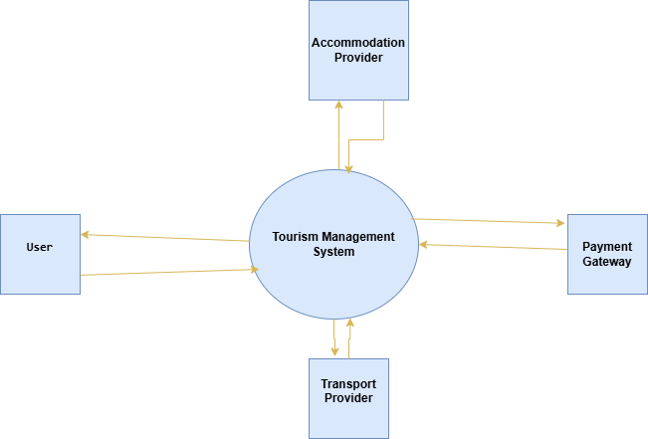

DFD LEVEL 0

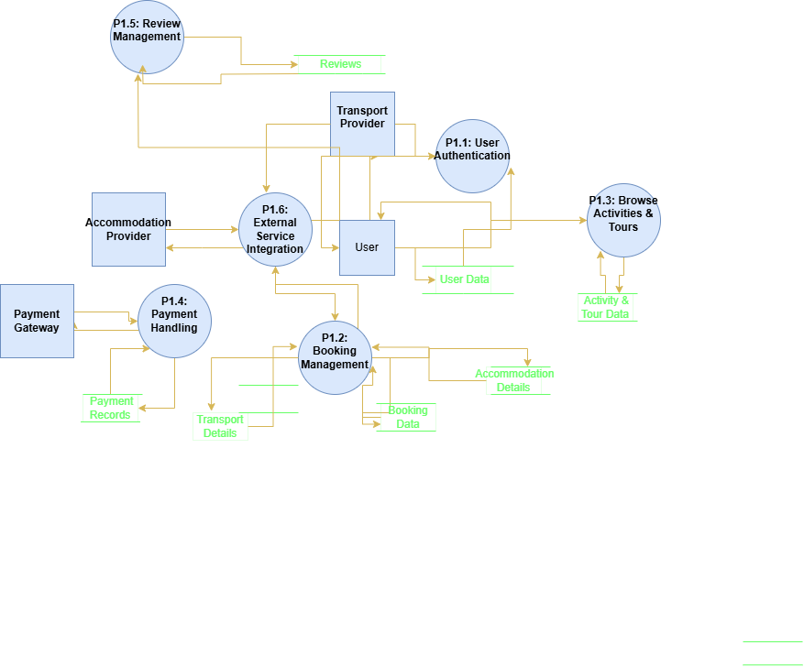

DFD LEVEL 1

-------------------------------------------------------------------------------------------------------------------------

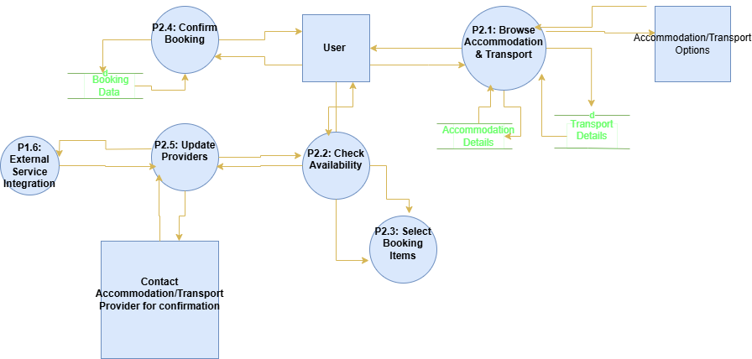

DFD LEVEL 2

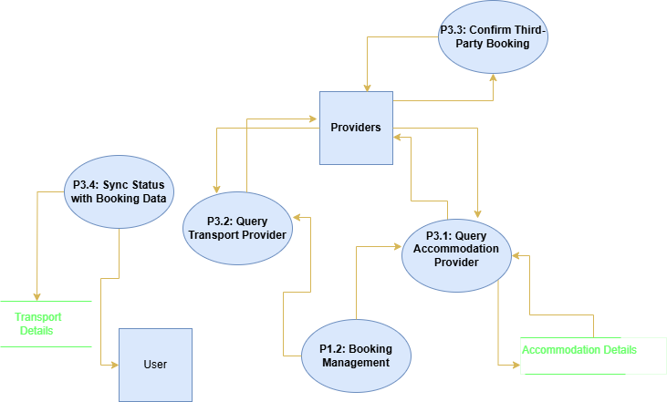

DFD LEVEL 3

6.2.Entity Relationship Diagram

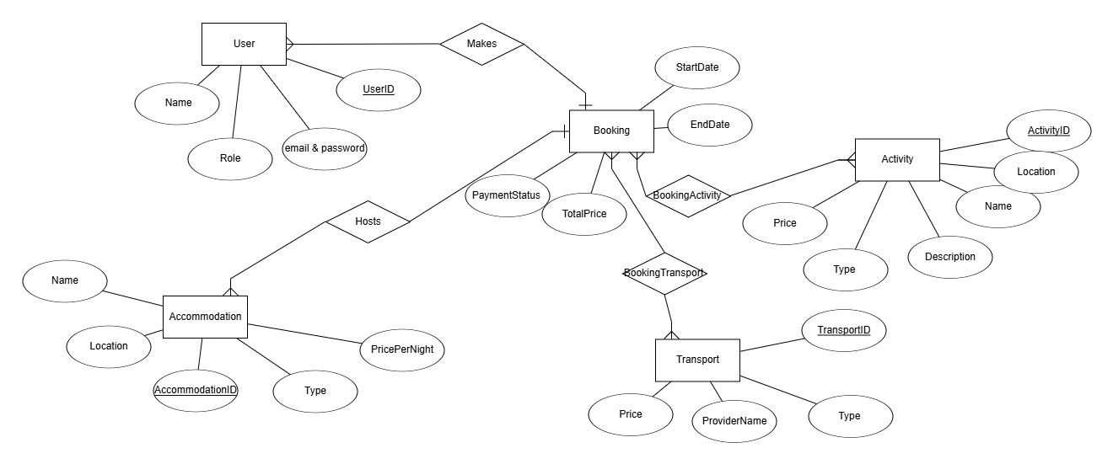

ERD

6.3.Class Diagram

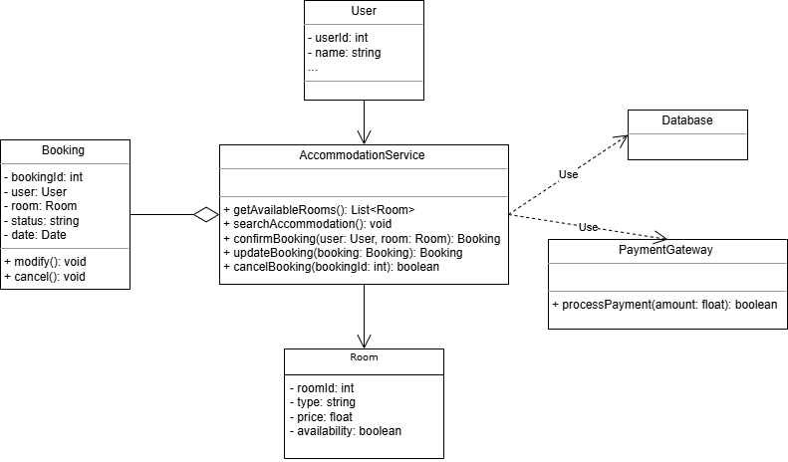

Accomodation Class Diagram

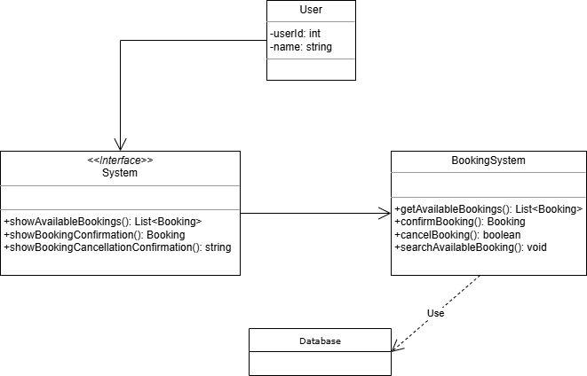

Booking Class Diagram

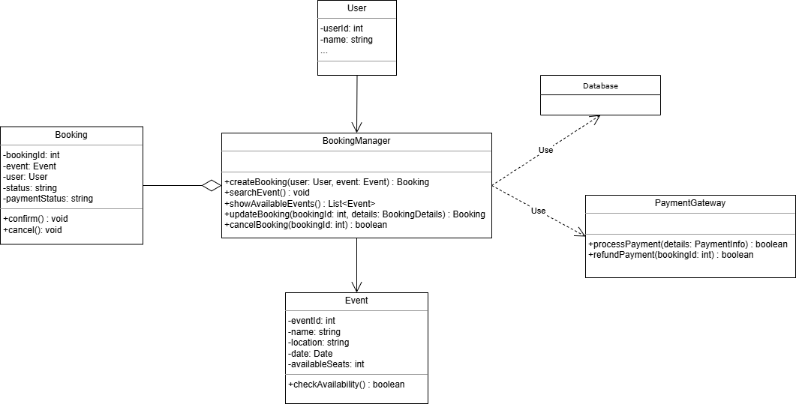

Event Class Diagram

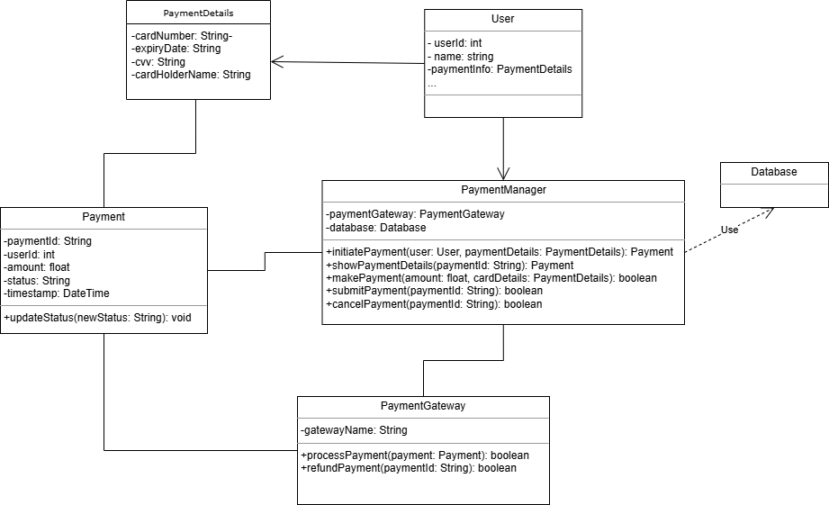

Payment Class Diagram

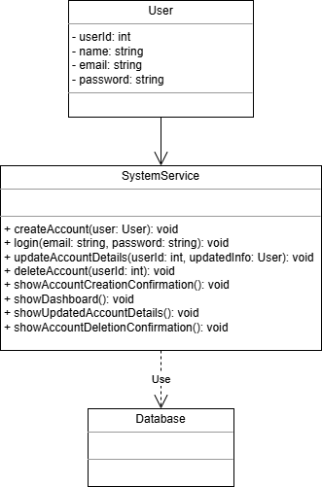

User Account Class Diagram

6.4.Object Diagram

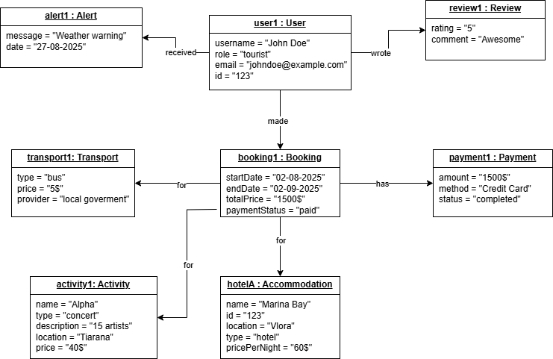

6.5.Sequence Diagram

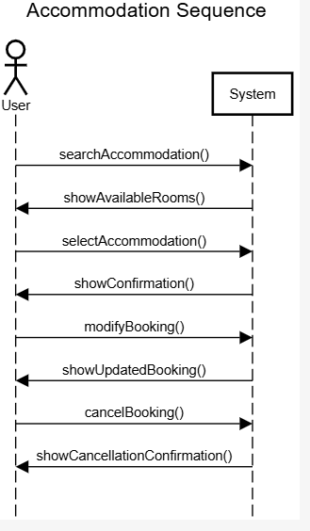 Accomodation Sequence Diagram

-------------------------------------------------------------------------------------------------------------------------

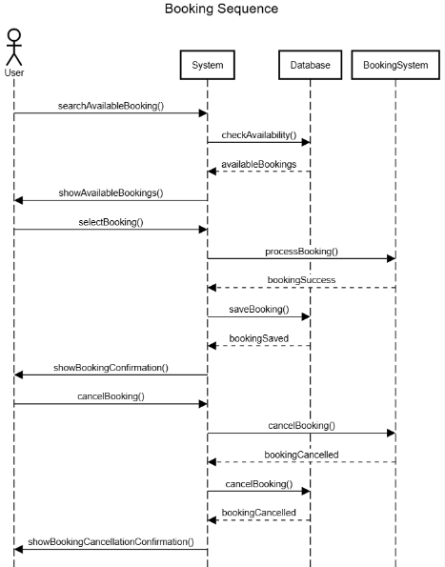 Booking Sequence Diagram

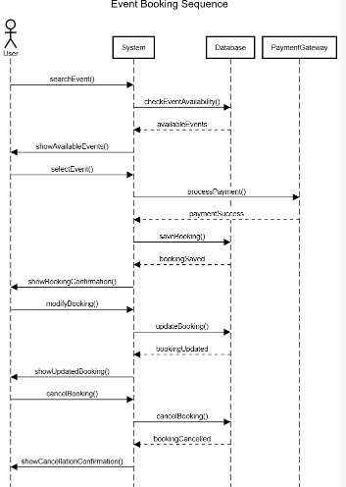 Event Sequence Diagram

--------------------------------------------------------------------------------------------------------------------------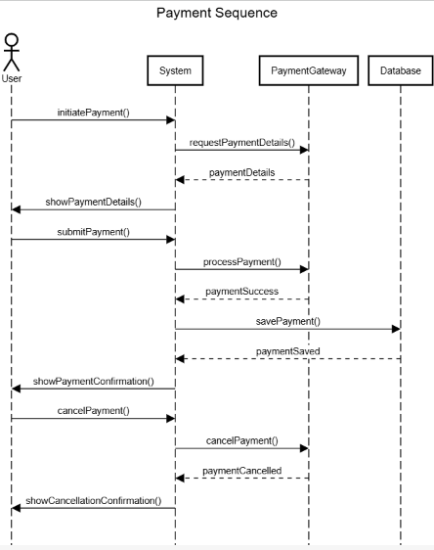 Payment Sequence Diagram

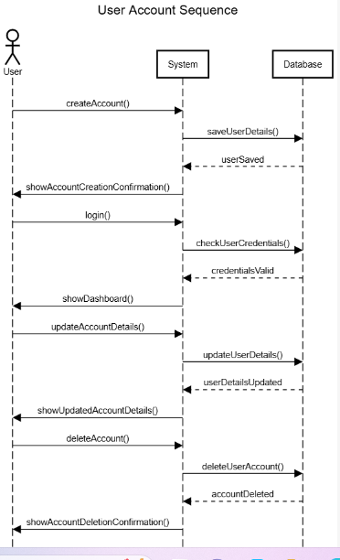 User Account Sequence Diagram

6.6.Collaboration Diagram

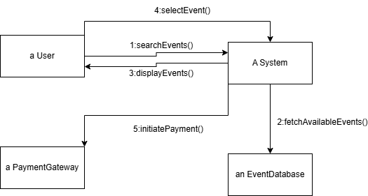

Event Booking Collaboration Diagram

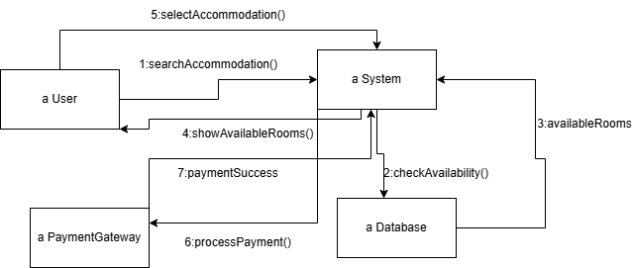

Accommodation Collaboration Diagram

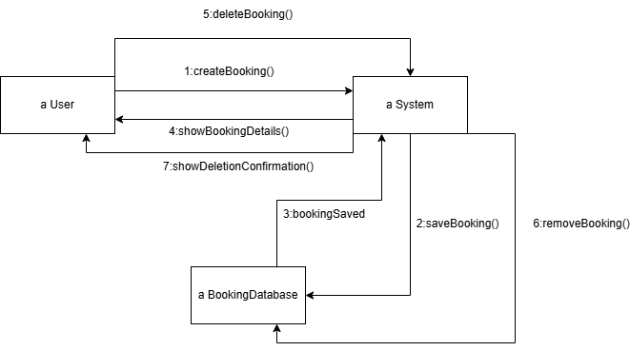

General Booking Collaboration Diagram

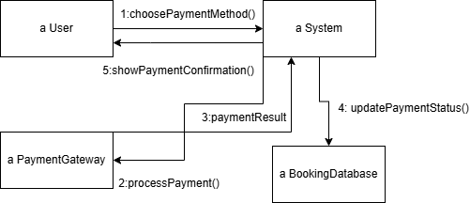

Payment Collaboration Diagram

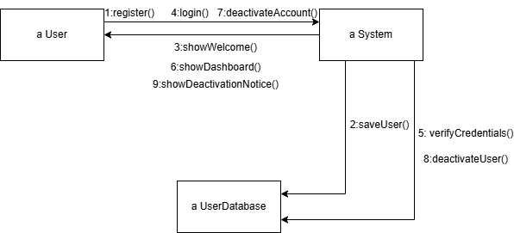

User Account Collaboration Diagram

6.7.Activity Diagram

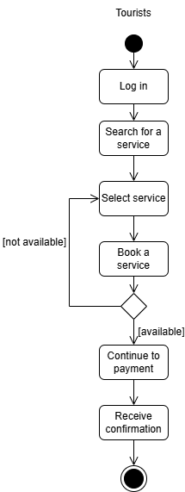 Booking Activity Diagram

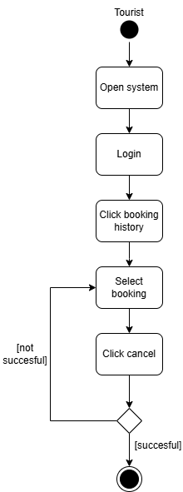 Cancel Booking Activity Diagram

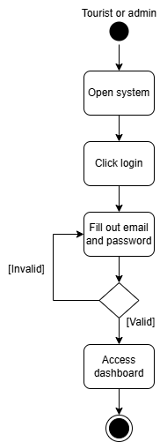 LogIn Activity Diagram

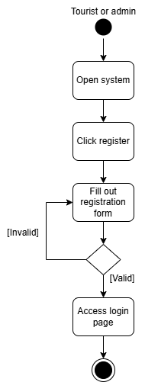 Register Activity Diagram

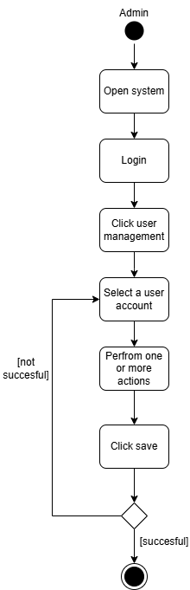

Manage Account Activity Diagram

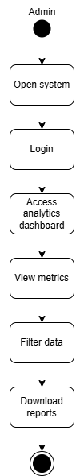

View Statistics Activity Diagram

6.8.State Diagram

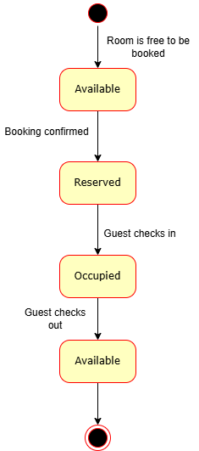

Accommodation State Diagram

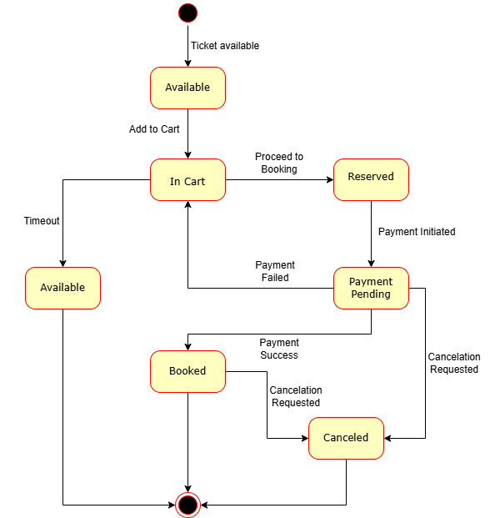

Event Booking State Diagram

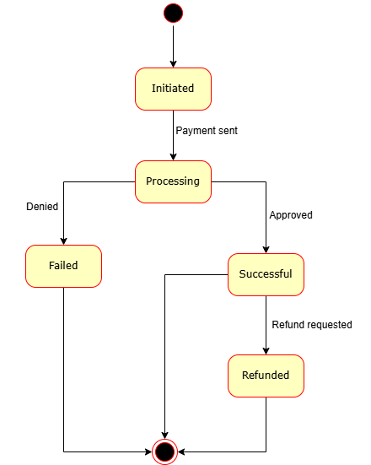

Payment State Diagram

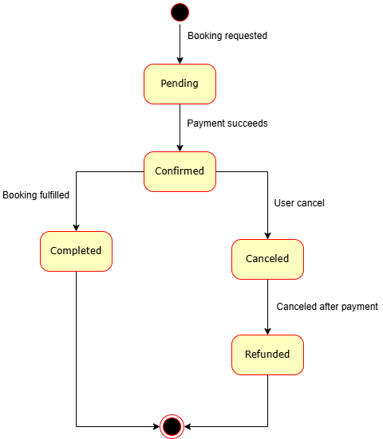

Booking State Diagram

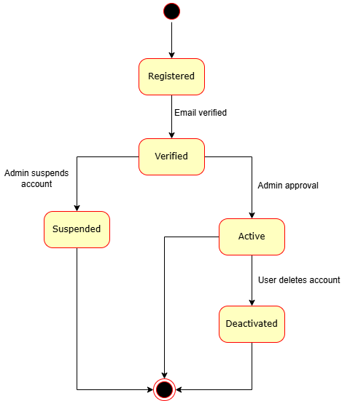

User Account State Diagram

6.9.Package Diagram

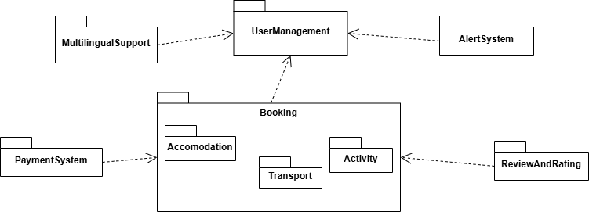

7.Component Diagram

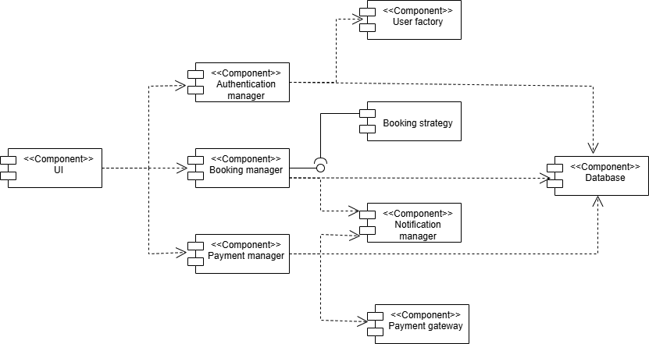

System Component Diagram

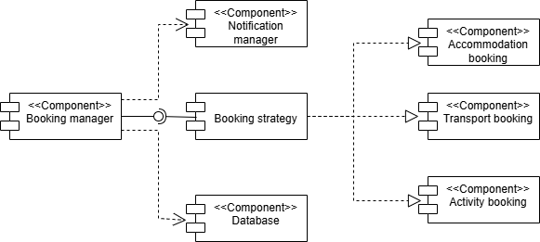

Booking Component Diagram

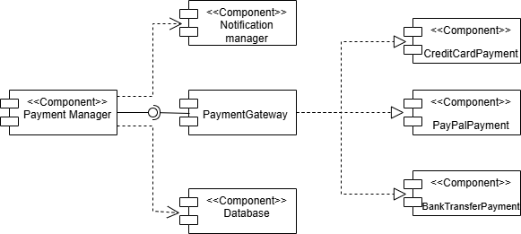

Payment Component Diagram

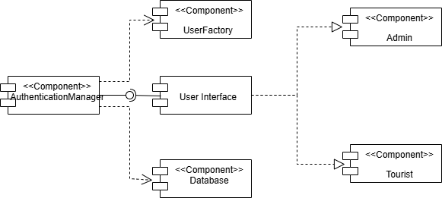

Authentication And User Component Diagram

8. Business Process Model and Notation (BPMN)

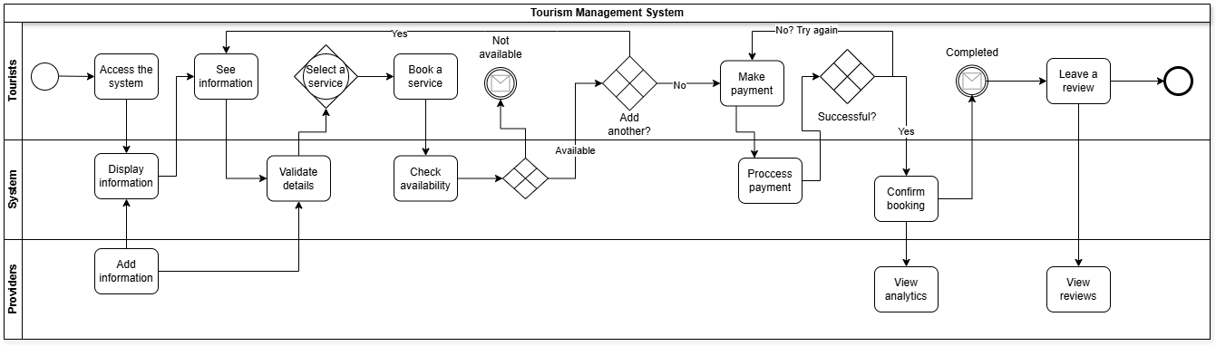

9.Design Patterns

9.1.Behavioral Design

9.1.1.Observer Pattern

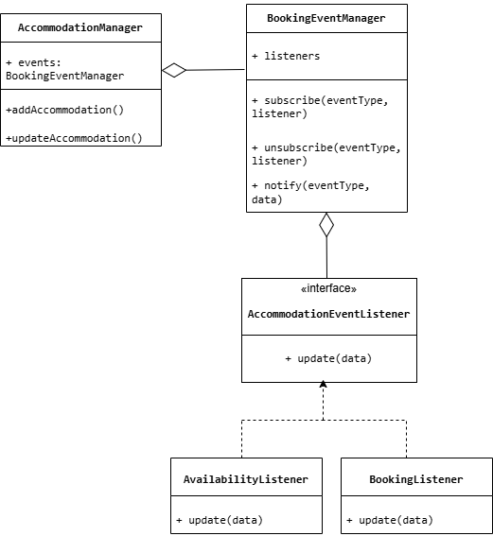

Accommodation Observer Diagram

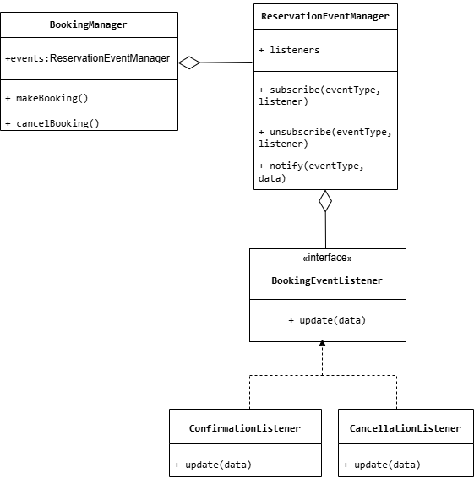

Booking Observer Diagram

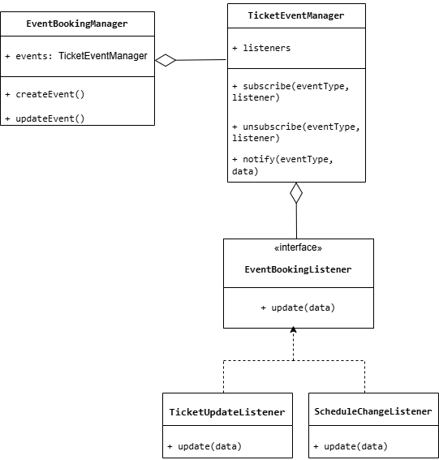

Event Booking Observer

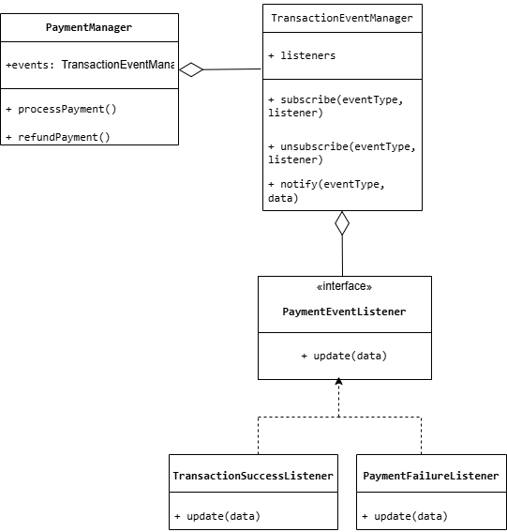

Payment Observer Diagram

9.1.2.Strategy Pattern

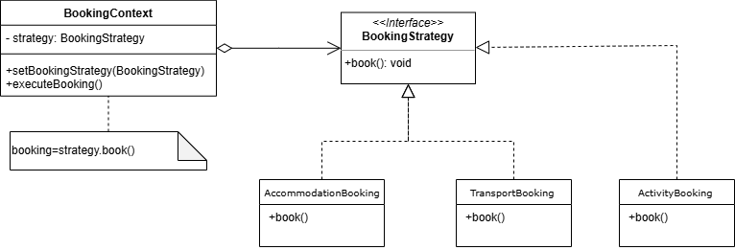

Booking Strategy Diagram

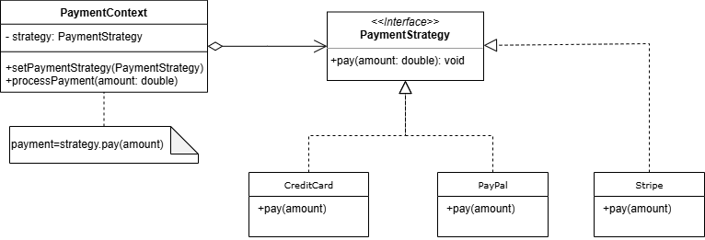

Payment Strategy Diagram

9.2.Creational Design

9.2.1.Factory Pattern

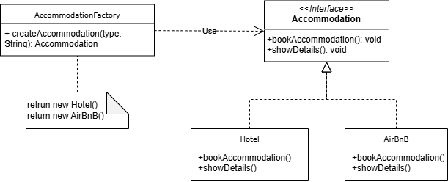

Accomodation Factory Diagram

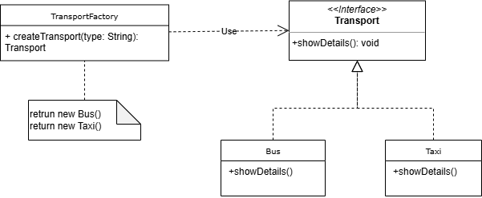

Transport Factory Diagram

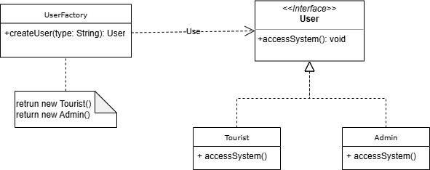

User Factory Diagram

9.2.2.Singleton Pattern

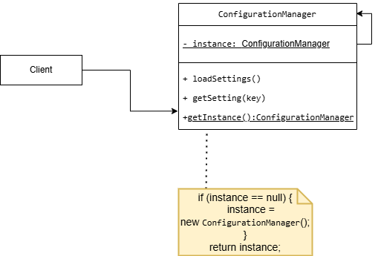

Configuration Manager Singleton Diagram

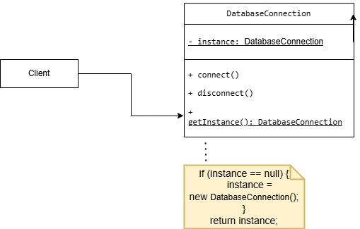

Database Connection Singleton Diagram

-----------------------------------------------------------------------------------------------------------------------

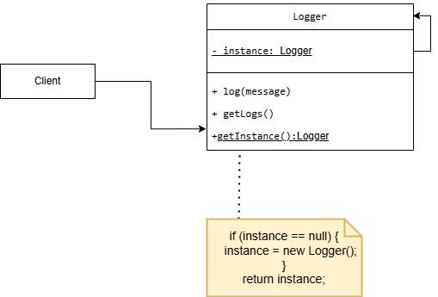

Logger Singleton Diagram

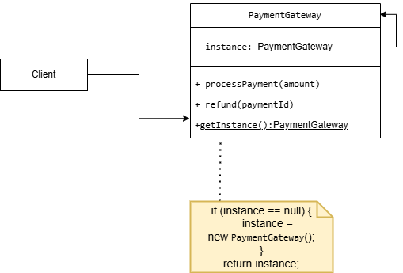

Payment Gateway Singleton Diagram

9.3.Structural Design

9.3.1.Decorator Pattern

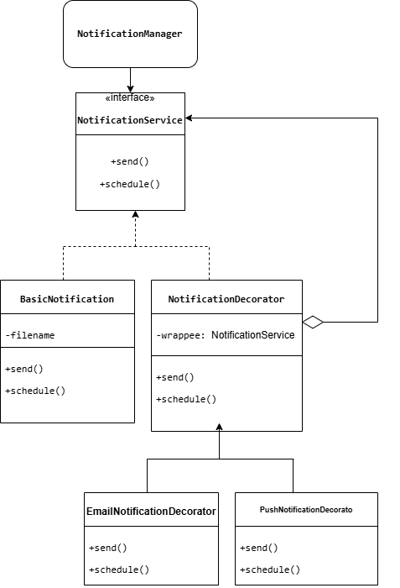

Notification Decorator Diagram

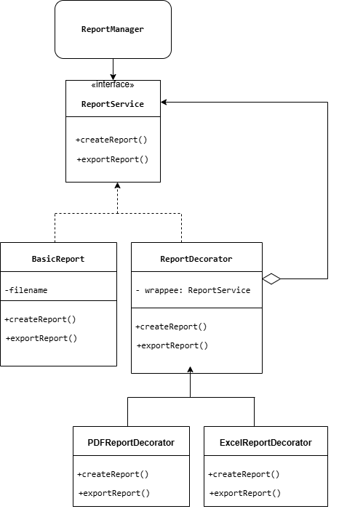

Report Decorator Diagram

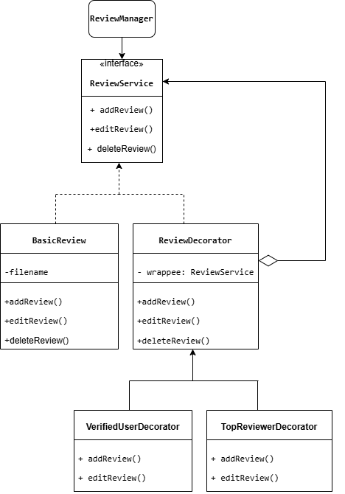

Review Decorator Diagram

10.Physical Design

10.1.Deployment Diagram

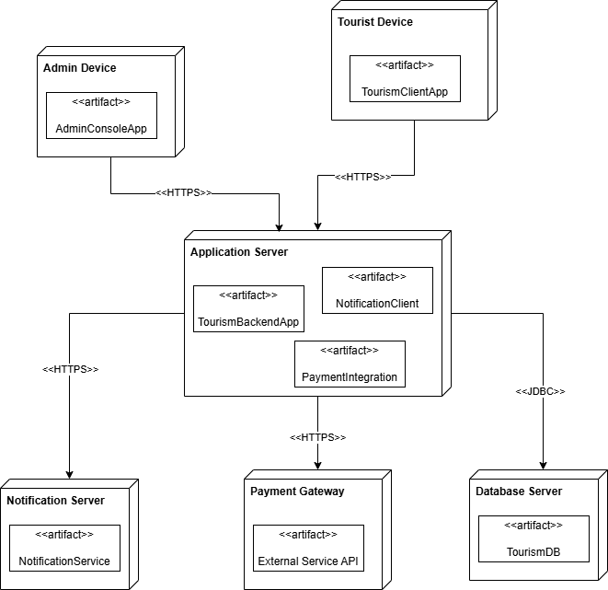

11.User Interface

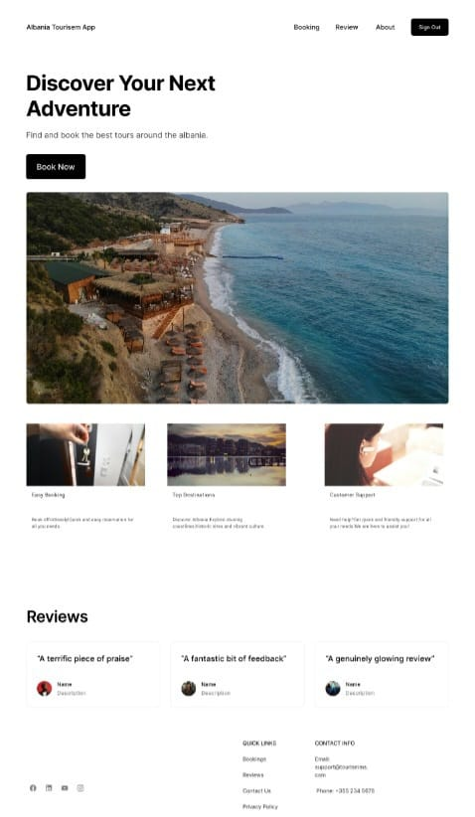

Home Section

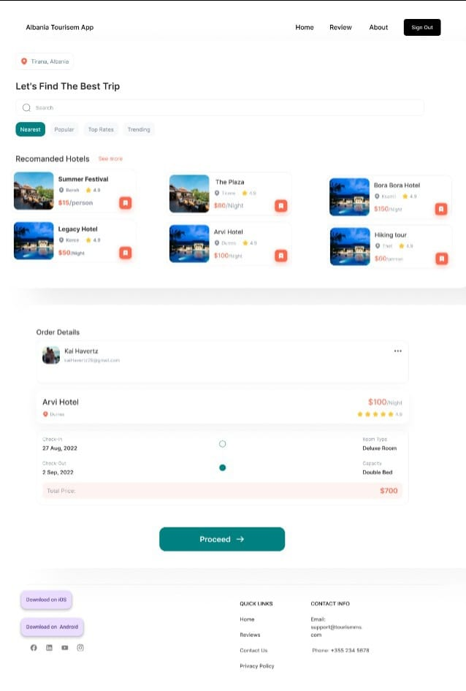

Booking Section

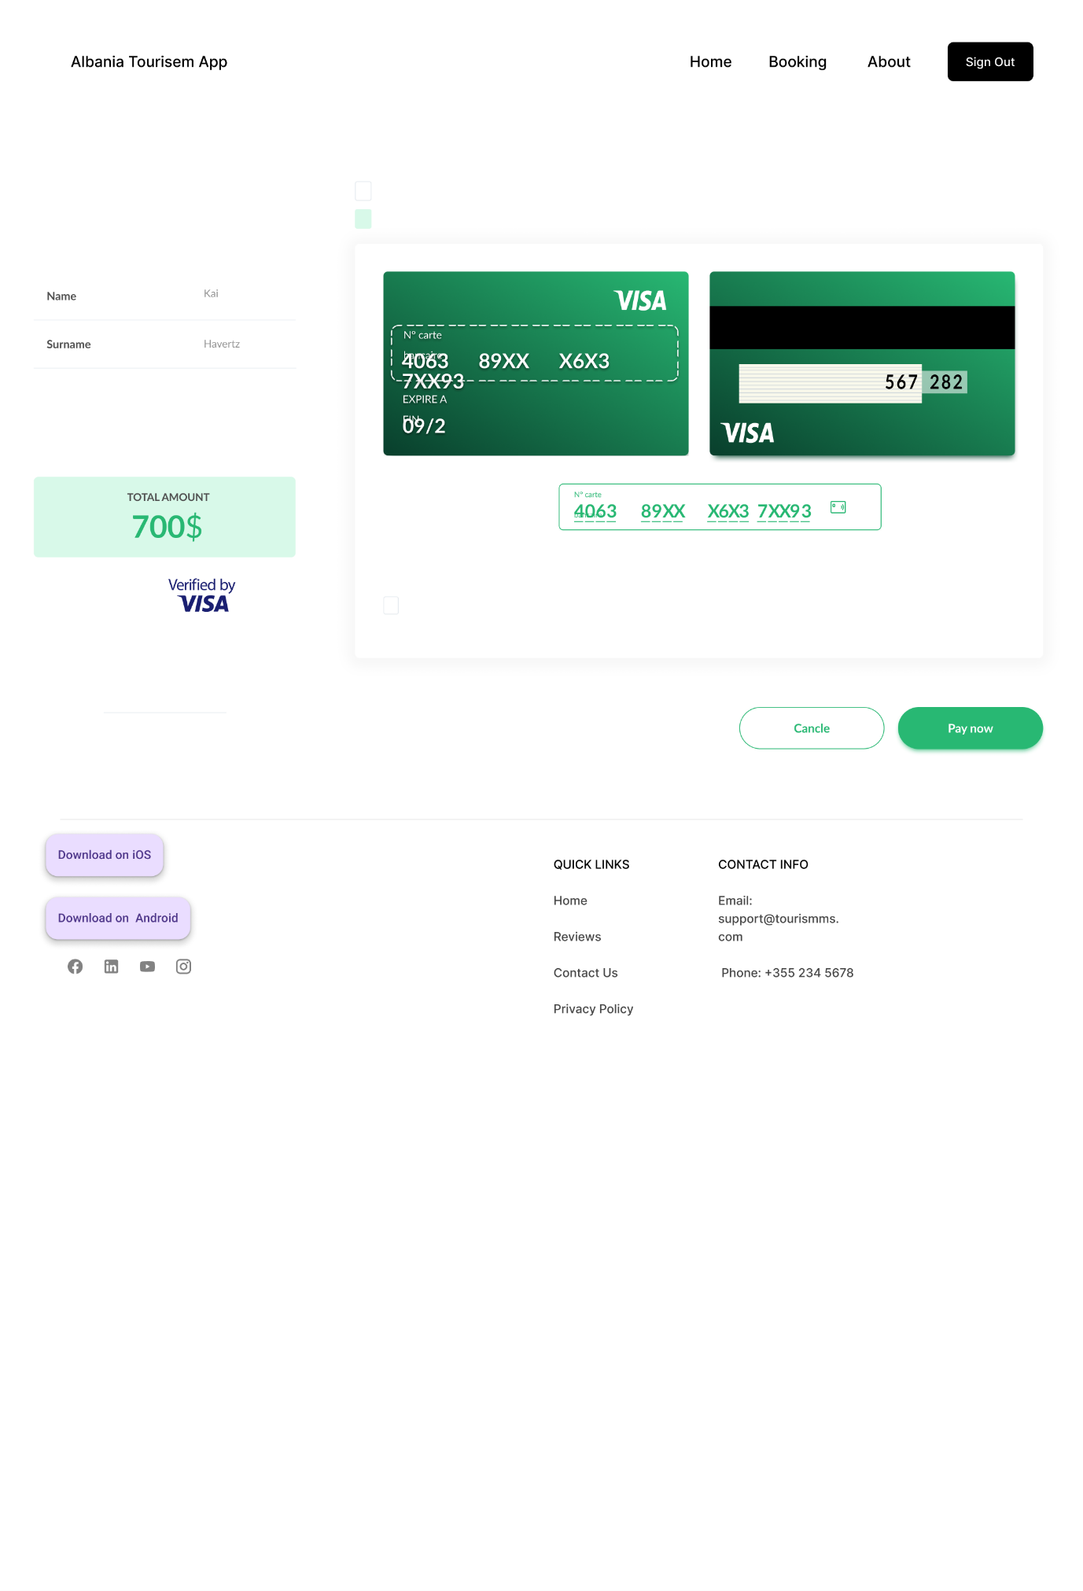

Payment Section

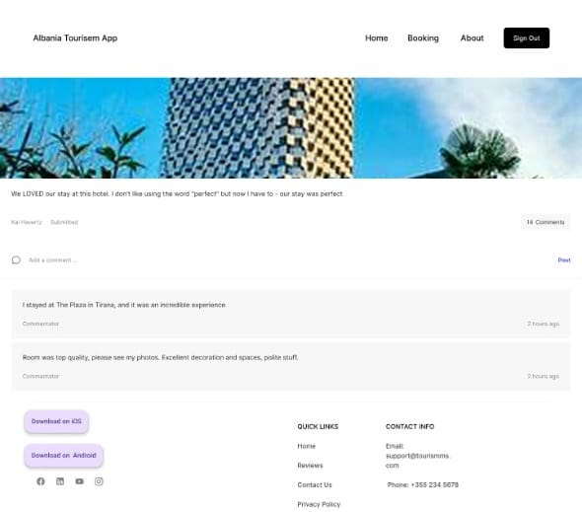

Review Section